Name: V.Sai Saketh Roll No:2520090023
Practical week-3
Query 1: Create the book_metadata table
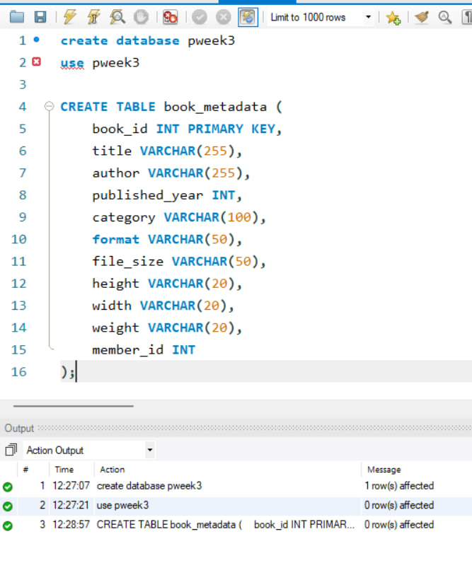
Query 2: Create the book_reviews table
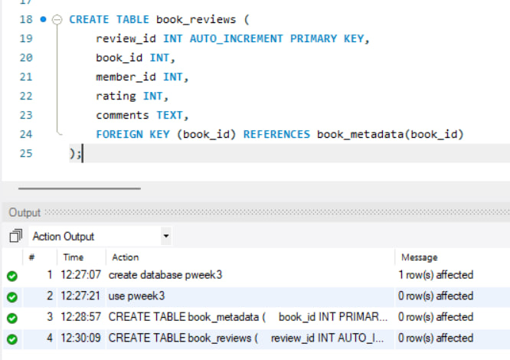
Query 3: Insert book metadata
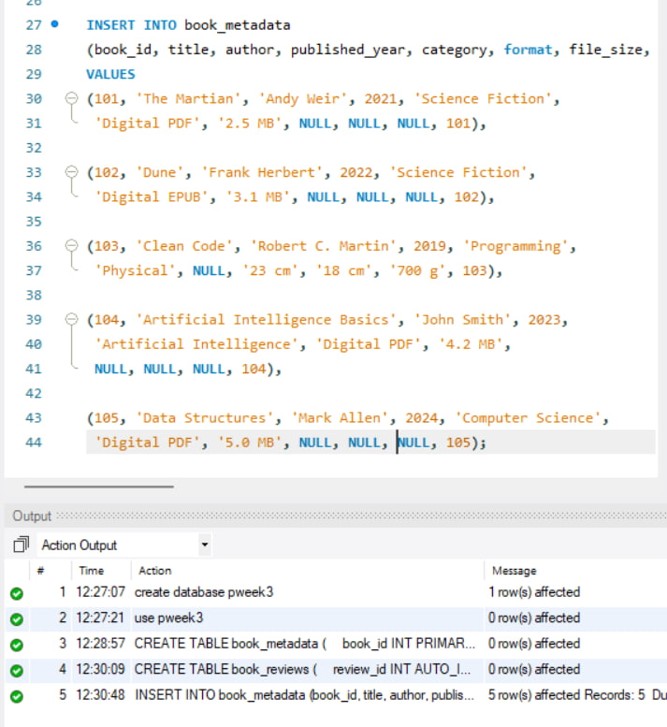

Query 4: Insert book reviews
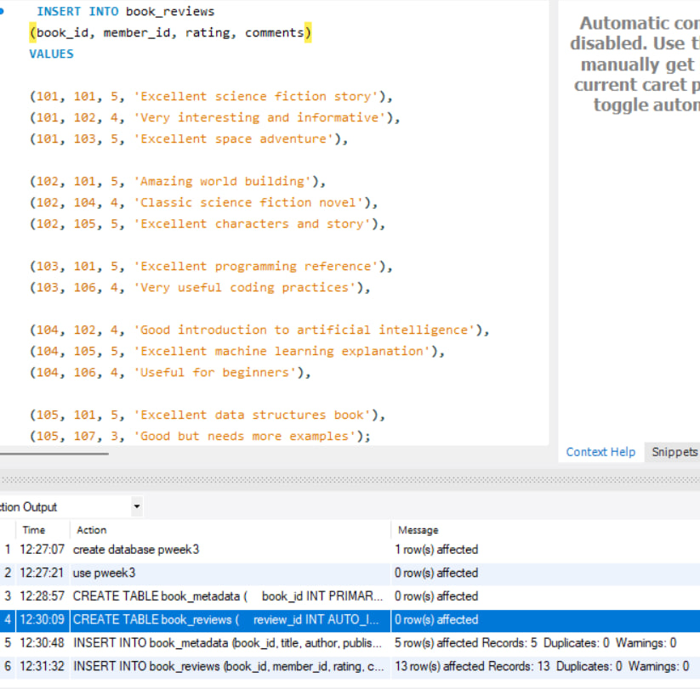
Query 5: Select all records from book_metadata
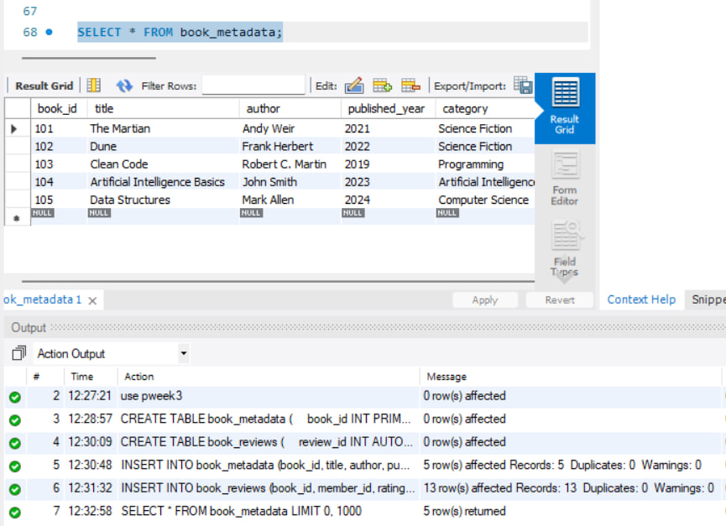
Query 6: Select all records from book_reviews
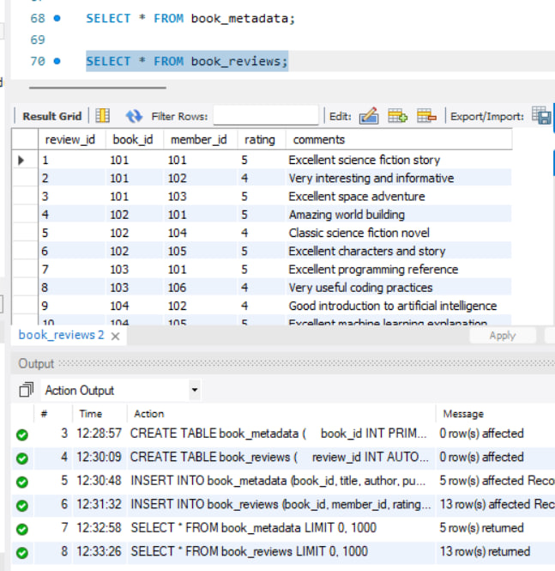

Query 7: Books with rating greater than 4
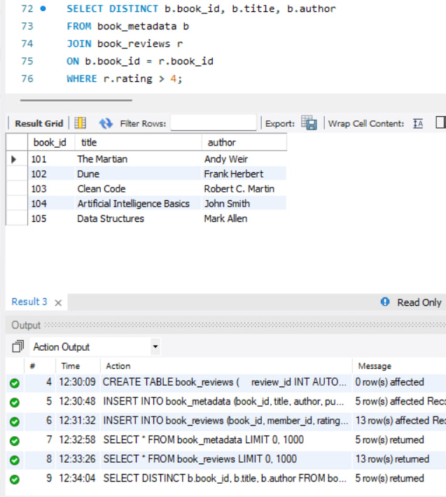
Query 8: Books with rating IN (4, 5)
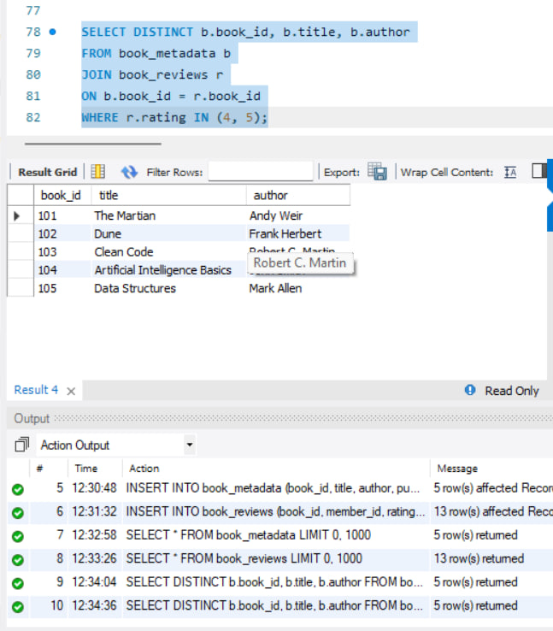
Query 9: Books with Digital format
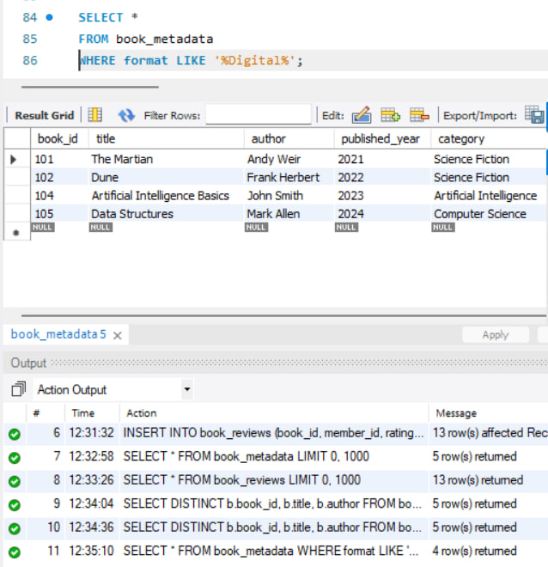

Query 10: Average rating and total reviews
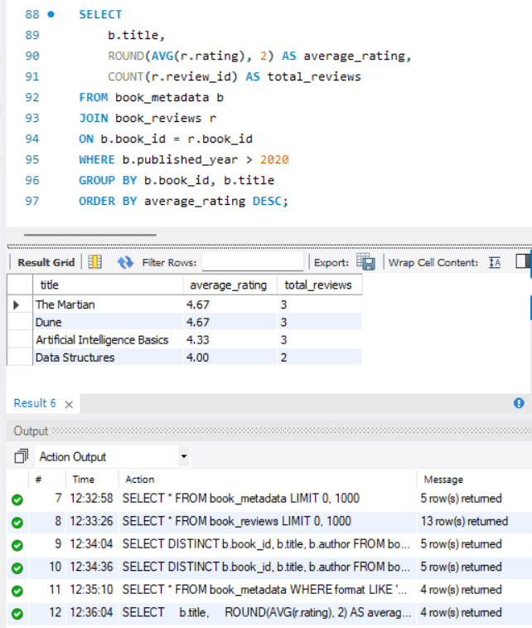
Query 11: Create FULLTEXT index on comments
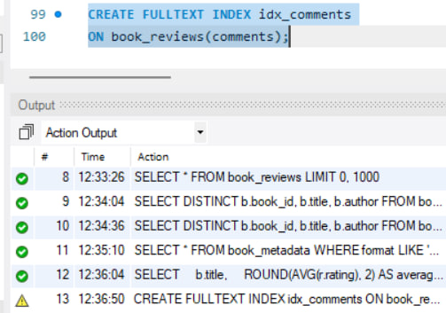

Query 12: FULLTEXT search for 'excellent'
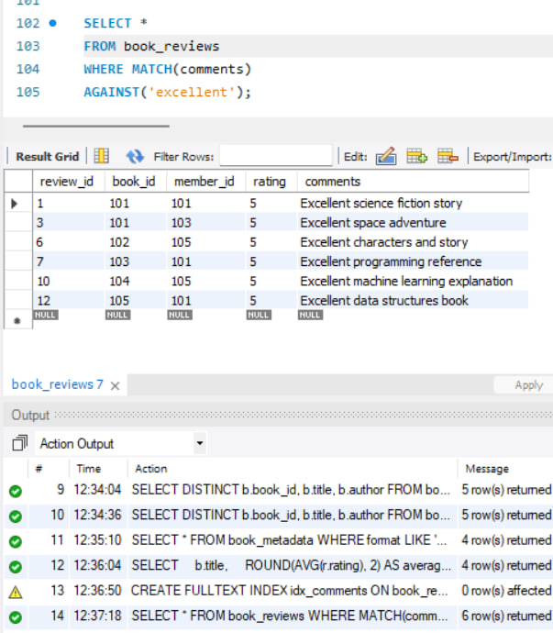
Query 13: FULLTEXT search for 'science fiction'
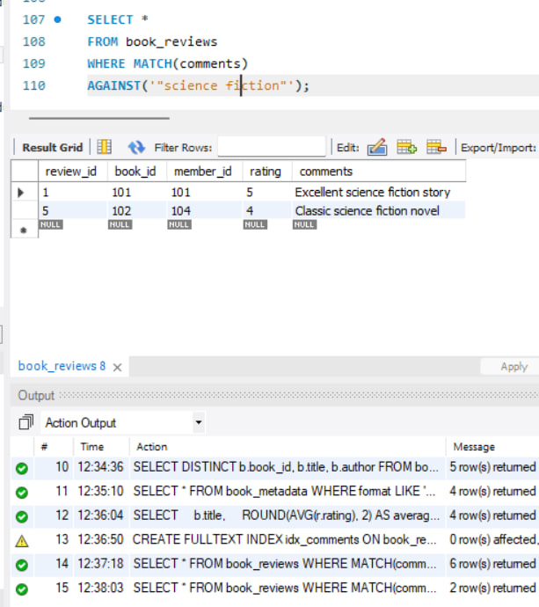

Query 14: EXPLAIN FULLTEXT search
